Appeal plays against batters who have hit doubles, triples or home runs

Rule 5.08(a) of the OBR, “HOW A TEAM SCORES”, states: EXCEPTION: A run is not scored if the runner advances to home base during a play in which the third out is made
- by the batter-runner before he touches first base;
- by any runner being forced out; or
- by a preceding runner who is declared out because he failed to touch one of the bases.

Example 11: With one out and bases loaded, the fourth batter hits a home run.
Before the pitcher makes his pitch to the new batter, he throws the ball to the first baseman who makes an appeal on first base on the grounds that the batter-runner missed first base.
The appeal is sustained by the umpire and the batter is called out.
In consequence of the appeal play the run scored by the batter who hit the home run is disallowed, but the others, remain valid, along with the advances.
WBSC |  | Traduction dans l’outil de scorage |  | Outil
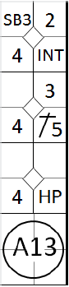 |  | /* Le premier batteur atteint la première base sur une interférence du receveur */  action { batter -> INT }  /* Le deuxième batteur frappe un hit sur la troisième base, le coureur avance */  action { batter -> 1B5, runner1 -> + }  /* Le coureur en 2 vole la troisième base */  action { runner2 -> SB }  /* le troisième batteur est touché par un lancé, le coureur en 1 avance */  action { batter -> HP, runner1 -> + }  /* le quatrième batteur frappe un homerun et fait rentrer tous les coureurs */  /* Il n'a pas touché la première base, le lanceur fait un appel en renvoyant la balle au défenseur de la première base */  action { batter -> A13, runner1 -> +++, runner2 -> ++, runner3 -> + } |  | 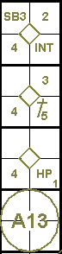

Example 12: With one out and bases loaded, the fourth batter hits a home run. The appeal play now is made on home plate.
The appeal is sustained, and the batter-runner is called out on home plate.
As a consequence of the appeal, the run scored by the batter who hit a home run is disallowed and he is credited with a triple.
The other three, remain valid.
WBSC |  | Traduction dans l’outil de scorage |  | Outil
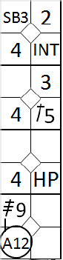 |  | /* Le premier batteur atteint la première base sur une interférence du receveur */  action { batter -> INT }  /* Le deuxième batteur frappe un hit sur la troisième base, le coureur avance */  action { batter -> 1B5, runner1 -> + }  /* Le coureur en 2 vole la troisième base */  action { runner2 -> SB }  /* le troisième batteur est touché par un lancé, le coureur en 1 avance */  action { batter -> HP, runner1 -> + }  /* le quatrième batteur frappe un home run dans le champ droit et fait rentrer tous les coureurs */  /* Il n'a pas touché la marbre, le lanceur fait un appel en renvoyant la balle au receveur */  action { batter -> 3B9 A12, runner1 -> +++, runner2 -> ++, runner3 -> + } |  | 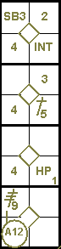

Example 13: With two out and a runner on second base, the batter hits a home run. While running the bases, the batter-runner misses first base. The home plate umpire gives the new ball to the pitcher and before the first pitch is made to the next batter, the defending team appeals against the batter-runner from first base.
The appeal is sustained and the batter-runner is called out on first base. The run scored by the runner who was on second base is therefore disallowed.
WBSC |  | Traduction dans l’outil de scorage |  | Outil
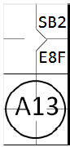 |  | /* Le premier batteur atteint la première base sur une erreur de rattraper de fly du champ centre */  action { batter -> E8F }  /* Le coureur en 1 vole la deuxième base */  action { runner1 -> SB }  /* Le deuxième batteur frappe un homerun, mais ne touche pas la première base. Un jeu d'appel est fait et le batteur coureur est retiré */  action { batter -> A13 } |  | 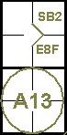
IMPORTANT: In the event that there are two men out and the hitter of the home run with runners on base is called out on appeal for having failed to touch a base other than first, the umpire shall allow the runs scored by those runners who touched the home plate before the batter reached the base that was the subject of the appeal. The opinion of the scorer in assigning runs should always be subordinate to that of the umpires.
NOTE: If the hitter of the home run is called out on appeal for having failed to touch second or third base, he is credited with either a single or a double.
In the final analysis it must be stated that when a batter, after having made a safe hit, is called out for having failed to touch a base, the last base he legally touched will determine the value of the hit that is recognized.
Thus, if he is called out for having failed to touch home plate, he will be credited with a triple; if he failed to touch third, a double; second, a single; if he failed to touch first he is called out and is not credited with a hit.
Example 14: With none or one out and bases loaded the batter hits the ball out of the park.
In the manner provided by the OBR, the defense appeals against the runner who was on third base for having failed to touch the home plate.
The appeal is sustained and as a consequence the first run scored is disallowed and the runner who had advanced is called out.
As a consequence of this appeal play three runs are scored, all batted in by the batter who hit the home run. The runners’ advances are all legal.
The consequences are similar when, with less than two out, any runner, with bases loaded, is called out on appeal for having missed one of the bases after the one where he started.
WBSC |  | Traduction dans l’outil de scorage |  | Outil
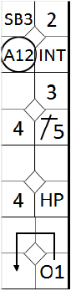 |  | /* Le premier batteur atteint la première base sur une interférence du receveur */  action { batter -> INT }  /* Le deuxième batteur frappe un hit sur la troisième base, le coureur avance */  action { batter -> 1B5, runner1 -> + }  /* Le coureur en 2 vole la troisième base */  action { runner2 -> SB }  /* le troisième batteur est touché par un lancé, le coureur en 1 avance */  action { batter -> HP, runner1 -> + }  /* le quatrième batteur frappe un homerun dans le champ droit et fait rentrer tous les coureurs. Le coureur qui part de la base 3 ne touche pas le marbre. Le lanceur fait appel en renvoyant la balle au receveur, le coureur est retiré */  action { batter -> O1+++, runner1 -> +++, runner2 -> ++, runner3 -> A12 } |  | 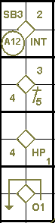

NOTE to examples 14 and 15: If a runner fails to touch a base to which he has not been forced to advance, in the event that an appeal is sustained, the batter shall be credited with the value of the base hit scored, it being understood that the runner is out in any case.
As regards the case given in the example, in application of rule9.05(b)(2) of the OBR, which states: “The official scorer shall not credit a base hit when … a batter apparently hits safely and a runner who is forced to advance by reason of the batter becoming a runner fails to touch the first base to which such runner is advancing and is called out on appeal,” score a putout for the runner and a fielder’s choice (occupied ball) for the batter-runner.
Example 15: With one out and bases loaded, the fourth batter hits a triple.
The defense appeals against the runner who was on third base, for having failed to touch home plate. The appeal is sustained, the first run scored is disallowed, and the lead runner is called out.
As a consequence of this appeal play, the number of runs scored is reduced to two, both of which were batted in by the batter who hit the triple. The advances made by the runners are all legal.
WBSC |  | Traduction dans l’outil de scorage |  | Outil
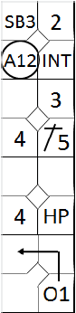 |  | /* Le premier batteur atteint la première base sur une interférence du receveur */  action { batter -> INT }  /* Le deuxième batteur frappe un hit sur la troisième base, le coureur avance */  action { batter -> 1B5, runner1 -> + }  /* Le coureur en 2 vole la troisième base */  action { runner2 -> SB }  /* le troisième batteur est touché par un lancé, le coureur en 1 avance */  action { batter -> HP, runner1 -> + }  /* le quatrième batteur frappe un triple dans le champ droit et fait rentrer tous les coureurs. Le coureur qui part de la base 3 ne touche pas le marbre. Le lanceur fait appel en renvoyant la balle au receveur, le coureur est retiré */  action { batter -> O1++, runner1 -> +++, runner2 -> ++, runner3 -> A12 } |  | 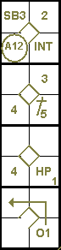
The action of the batter-runner is scored as a fielder’s choice (O1), according to the provisions of rule 9.05(b)(2) of the OBR. It is worth noting that if any of the other runners had been put out it would have had the same effect on the batter-runner.
Example 16: With one out and bases loaded, the fourth batter hits a triple.
The defense appeals against the runner who started from first base, for having failed to touch home plate. The appeal is sustained and in consequence the final run scored is disallowed and the runner against whom the appeal was made is called out.
The effect of this appeal play is that the number of runs scored is reduced to two, both of which were batted in by the batter who hit the triple. The advances made by the runners are all legal.
The action of the batter-runner is recorded as a two-base hit, and an fielder’s choice to indicate that he reached third base[OBR rule 9.06(b) Comment].
WBSC |  | Traduction dans l’outil de scorage |  | Outil
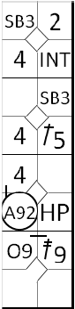 |  | /* Le premier batteur atteint la première base sur une interférence du receveur */  action { batter -> INT }  /* Le deuxième batteur frappe un hit sur la troisième base, le coureur avance */  action { batter -> 1B5, runner1 -> + }  /* Le coureur en 2 vole la troisième base */  action { runner2 -> SB }  /* le troisième batteur est touché par un lancé, le coureur en 1 avance */  action { batter -> HP, runner1 -> + }  /* le quatrième batteur frappe un triple dans le champ droit et fait rentrer les deux trois coureur */  /* Le coureur qui part de la base 1 ne touche pas le marbre */  /* Le défenseur du champ droit fait appel en renvoyant la balle au receveur, le coureur est retiré */  action { batter -> 2B9 O9, runner1 -> ++ A92, runner2 -> ++, runner3 -> + } |  | 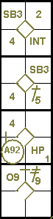

Example 17: With two out and runners on first and third, the batter hits a double, as a result of which both runners score.
Before the next pitch is thrown, the pitcher throws the ball to the third baseman and the defense appeals that the second unner has missed third base. The appeal is sustained and as a consequence the runner is called out.
Only the first run, which was batted in, is allowed, and the batter-runner is credited with a single. A fielder’s choice is written to indicate that he reached second base.
WBSC |  | Traduction dans l’outil de scorage |  | Outil
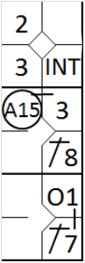 |  | /* Le premier batteur atteint la première base sur une interférence du receveur */  action { batter -> INT }  /* Le deuxième batteur frappe un hit sur le champ centre, le coureur avance de deux bases */  action { batter -> 1B8, runner1 -> ++ }  /* le troisième batteur frappe un double sur le champ gauche. Le coureur qui part de la base 1 ne touche pas la troisième base. Le lanceur fait donc appel en relayant la balle au défenseur de la troisième base, le coureur est retiré */  action { batter -> 1B7 O1, runner1 -> + A15, runner3 -> +} |  | 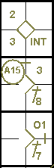

Example 18: With two out and bases full, the batter hits a home run.
Before the runner who was on first base can touch third, he is over taken by the batter-runner, who is called out by virtue of rule 5.09(b)(9) of the OBR.
Two runs are nevertheless scored: the runner from first base is deemed to have reached second safely and the batter-runner is credited with a double and an automatic putout.

WBSC |  | Traduction dans l’outil de scorage |  | Outil
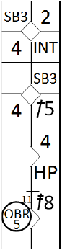 |  | /* Le premier batteur atteint la première base sur une interférence du receveur */  action { batter -> INT }  /* Le deuxième batteur frappe un hit sur la troisième base, le coureur avance */  action { batter -> 1B5, runner1 -> + }  /* Le coureur en 2 vole la troisième base */  action { runner2 -> SB }  /* Le coureur en 1 vole la deuxième base */  action { runner1 -> SB }  /* le troisième batteur est touché par un lancé */  action { batter -> HP }  /* le quatrième batteur frappe un homerun dans le champ centre et fait rentrer les deux premier coureurs. Le batteur coureur double le coureur venant de la une avant que celui-ci n'atteigne la troisième base. L'exemple fournit par le document semble faut Le dernier batteur gagnerais la deuxième base alors qu'elle est occupée */  action { batter -> 2B8 OBR11-5, runner1 -> ++ , runner2 -> ++, runner3 -> + } |  | 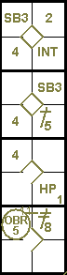

Example 19: if, however, the batter-runner is called out before the second runner touches home plate, only one run is scored, as the second run would have been scored after the third putout.
WBSC |  | Traduction dans l’outil de scorage |  | Outil
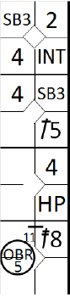 |  | /* Le premier batteur atteint la première base sur une interférence du receveur */  action { batter -> INT }  /* Le deuxième batteur frappe un hit sur la troisième base, le coureur avance */  action { batter -> 1B5, runner1 -> + }  /* Le coureur en 2 vole la troisième base */  action { runner2 -> SB }  /* Le coureur en 2 vole la troisième base */  action { runner1 -> SB, runner2 -> SB }  /* le troisième batteur est touché par un lancé */  action { batter -> HP }  /* le quatrième batteur frappe un homerun dans le champ centre et fait rentrer le premier coureur. Le batteur coureur double le coureur venant de la une avant que celui-ci n'atteigne la troisième base. L'exemple fournit par le document semble faut Le dernier batteur gagnerais la deuxième base alors qu'elle est occupée */  action { batter -> 1B8 OBR11-5, runner1 -> + , runner2 -> +, runner3 -> + } |  | 